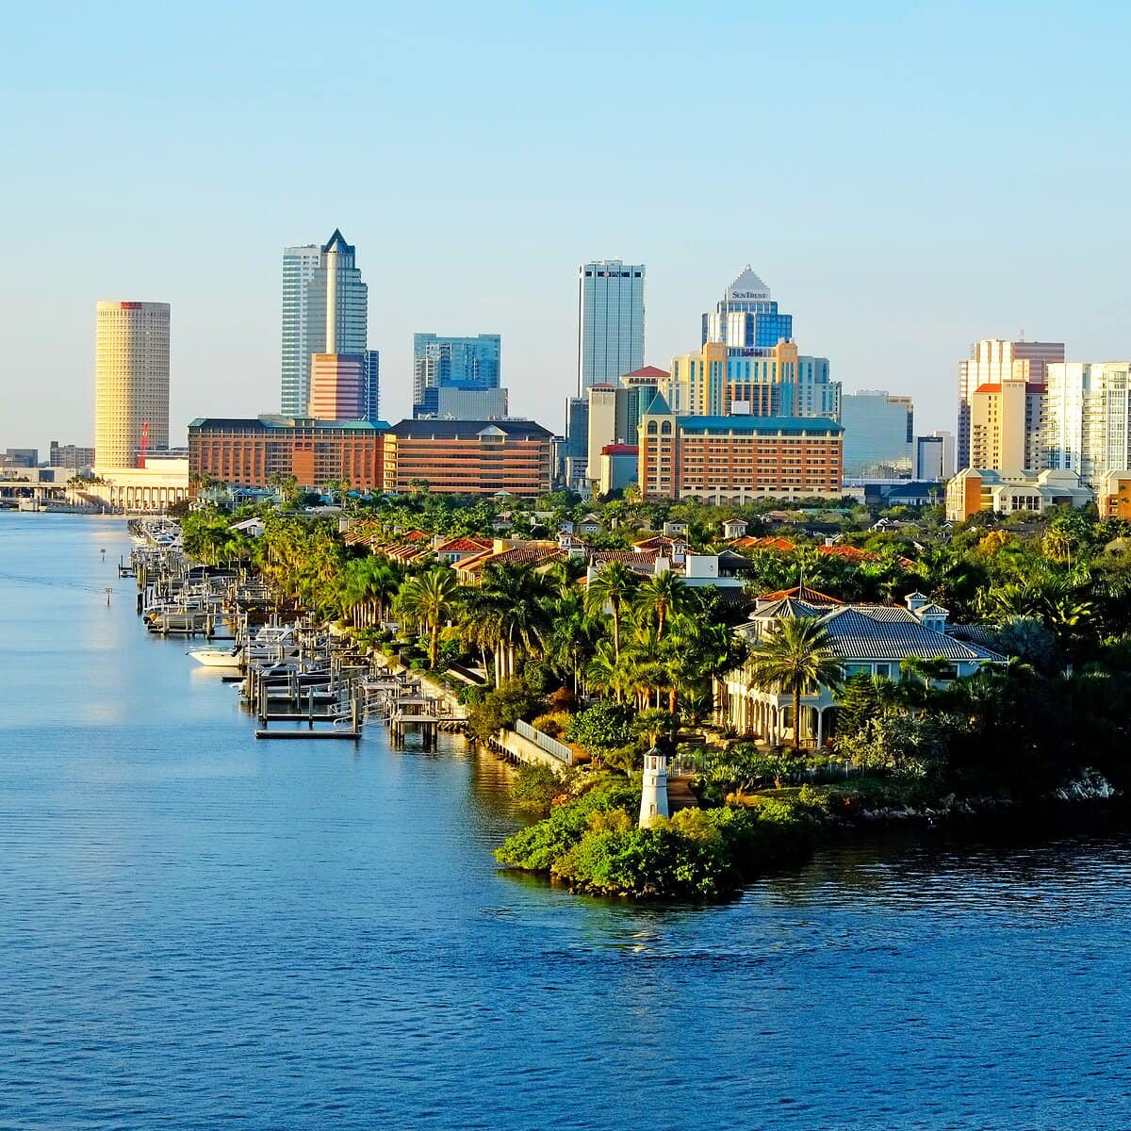
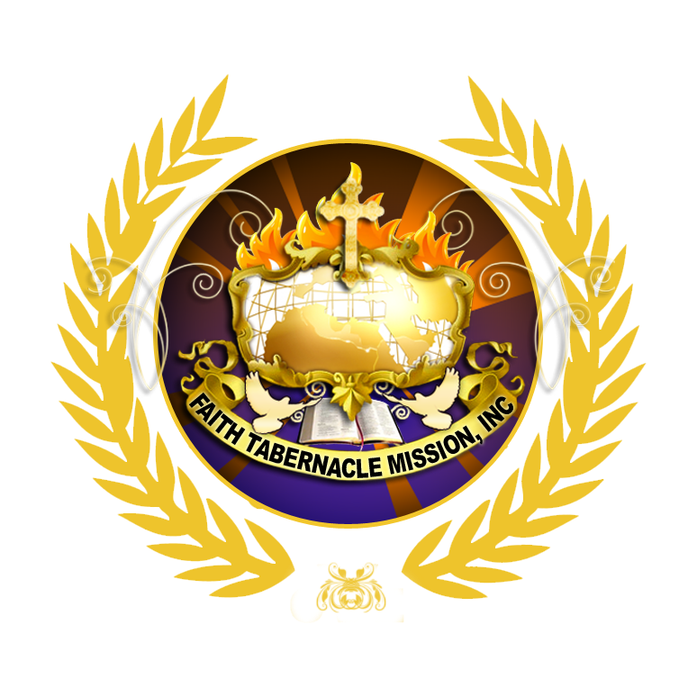

FAITH TABERNACLE MISSION
CONTENTS
Dear Friends………………………….3
Our Beginning………………………..4
Our Mission…………………………..5
Our Values……………………………7
Statement of Faith………………….11
Connect Groups / Serving…………15
What To Expect……………………..16
Stay Connected………………………18

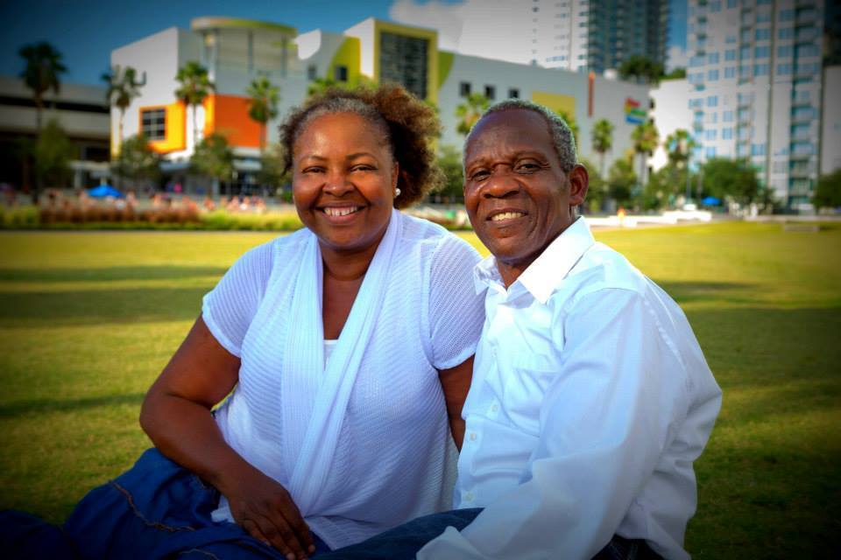

D
ear friends, we have put this together to let you know a little bit about ourselves and our history, our values, and our core beliefs.
Please take time to prayerfully consider this as you make a decision to join our church family. We look forward to getting to know you and answering any questions you may have.

Much love,
Drs. Marcel & Nicole Ternival
& the FTM Leadership Team

OUR BEGINNING

Faith Tabernacle Mission Faith Tabernacle Mission was founded in 1978 by Pastors Marcel and Nicole Ternival in Croix-des Bouquet, Haiti. Under the direction of the Holy Spirit, they have seen many souls coming into the Kingdom of God. People have been delivered and set free by the power of the Holy Spirit.
Currently, the ministry includes more than 40 churches, three schools, a Christian radio station, and the River Bible institute of Haiti.

Faith Kids of Haiti school focuses on the educational, physical, emotional, and spiritual needs of kids; in order to achieve our mission to help Haitian children be future Christian leaders.
The school provides quality education, nutritious meals, and clean shelter. The school works to equip a minimum of 500 students with a Christian education and life skills.

They start a church under the covering of Faith Tabernacle Mission International (FTMI). (FTMI) is an Apostolic
Prophetic Team led by our Associate Pastors.

For more information on FTM you can visit their web page at www.FTmission.org

OUR

MISSION

To know Jesus and to make him known

OUR

MANDATE

A gathering that elevate Jesus, Evangelize, healing, training,

sending church.

WE HAVE A DREAM

To establish a multicultural community of friends where people are loved, forgiven, and accepted; a safe place where people can be restored, trained, and take what they have learned and spread it to their neighbors and to the nations. To be a gathering, healing, training, sending church.

THE MODEL

Our church is led by a team of Elders who oversee the different ministries in the life of the church. The Eldership Team is accountable to an apostolic team called “New Covenant Ministries International” (www. FTmission.org)

Our goal is to equal people for works of service
(Ephesians 4:11-16) and thereby fulfill the great commission (Matthew 28:16-20). Our heart is to see everyone fulfill their God given purpose.

OUR VALUES

OUR VALUES ARE OUR TREASURE

Rather than rules, our values are essential building blocks that are born out of our convictions about how we should live according to God's Word.
We do our best to focus on and embody the following core values as a church.

THE BIBLE

The Bible in its entirety is the inspired and authoritative Word of God and is the only acceptable standard for life, ministry, and conduct in the church (2 Timothy 3:1-17)

THE MOBILIZATION OF EVERY BELIEVER
For strong relationship is important to us. Through our friendships, we function with the desire to empower and involve all believers so they can embrace their part in God's mission for us. (1 Peter 2:9-10)

GENEROSITY
We aim to resource all aspects of ministry with our finance, gifting, and people, our finances to resource ministry are obtained through tithes (10% of your income) and offerings.

FAMILY

Family is important in all that we do. We strive for the integration of all ages, races, and cultures, walking and working together in a multi-generational and multi-faceted expression of all that God has intended for us and called us to (Acts 2:42-47).

PRAISE & WORSHIP

We believe that worship is a lifestyle and not just a Sunday activity. We seek to worship God in all that we do, keeping Christ central and expressing worship in creative and diverse ways.

PRAYER

We acknowledge the total need for God and His Spirit in every area of our lives, therefor prayer and spiritual warfare precedes all that we do.

THE GIFTS OF THE SPIRIT

We desire the Gifts of the Spirit to be manifest in and through our lives on an individual and corporate basis as we function as the body under the headship of Christ (1 Corinthians 14:1).

WINNING SOULS FOR DISCIPLESHIP

We aim to evangelize, care for, and grow individuals in Christ as we reach into our community and the nations with the Gospel; thereby fulfilling the Great Commission (Matthew 28:16-20).

For details on how to get connected, check out our Connect Group Card. Visit www.FTmission.org, or call (813) 419-0920

STATEMENT OF FAITH

We believe that is important for you to know what our essential beliefs are at Faith Tabernacle Church. The following represents our core beliefs:

- In the Scriptures of the Old and New Testaments in their original writing as fully inspired by God, and accept them as the full and final authority for faith and life.
- In one God eternally existing in three persons- Father, Son and Holy Spirit.
- That the Lord Jesus Christ was begotten by the Holy Spirit, born of the Virgin Mary, and is true God and true Man.
- That God creates man in His image; that man sinned and thereby incurred the penalty of death, physical and spiritual, and that all human beings inherit a sinful nature which issues in actual transgression involving personal guilt.
- That the Lord Jesus Christ died for our sins, a substitutionary sacrifice, according to the Scriptures, and that all who believe and trust in Him are justified on the grounds of His shed blood.
- In the bodily resurrection of the Lord Jesus Christ, His ascension into heaven, and His present life as our High Priest and Advocate.
- In the personal return of the Lord Jesus Christ.
- In the personality of the Holy Spirit, His regenerating work, and abiding presence in the true believer. That the Holy Spirit indwells all true believers and that He has been sent to be the Comforter and Empowerment of Christian Church, to produce the fruit of the Holy Spirit and the gifts of the Holy Spirit according to the Scriptures.
- That all who repent of their sin and receive the Lord Jesus Christ by faith are born again of the Holy Spirit and thereby become children of God.
- That all Christians are called to life of holiness, devotion to the Lord Jesus Christ and service to Him.
- In the resurrection both of the just and the unjust, the eternal blessedness of the redeemed, and the eternal banishment from God of those who have rejected the offer of salvation.
- That the whole company of those who have accepted the Lord Jesus Christ as their Savior have been redeemed by Him and regenerated by the Holy Spirit and form the one true Church , and that each local church on earth should take its character from this concept. Therefore, the new birth and personal confession of faith in Christ are essentials of the Church membership.
- In the priesthood of all believers in Jesus Christ.
- That the ascended Christ has given various ministries or ministers of the Church in order to bring all the believers to the place of Christian maturity in the understanding of truth, and the performance and function of the ministry ( Ephesians :4:11; Romans 12:4-8 and Corinthians 12:10)
- That the healing of the sick in the name of Jesus Christ is still active in the Church ( Mark 16: 16-18; Mathew 8:16-17; 1 Corinthians 12:9; James 5: 14-15)
- That God never removed the gifts of the Holy Spirit from the Church, and that the Scriptural commands to “seek earnestly the best gifts” and to “ forbid not to speak in tongues”, are still applicable today ( 1 Corinthians 12,13 & 14:1-39)
- That the miracles as recorded in the Bible were real miracles and are possible in the preset day ( John 14:12 an 1 Corinthians 12:10)
- That all believers are called to fulfill the Great Commission (Matthew 28:18-20). That Christ is the Head of His body, the Church and that in all things He has pre-eminence.

CONNECT GROUPS / SERVING

Connect Group are an integral part of biblical Christianity (Act 2: 46, 5: 42, and 20:20). They are a wonderful place to do life together, to cultivate friendships, to study The Bible and further our relationships with God, with one another and with our city.

If you’re thinking about making Faith Tabernacle Church your home, a Connect Group is a great way to start.

For details on how to get connected, check out our Connect Group Card. Visit www.FTmission.org, or call (813) 419-0920

WHAT TO EXPECT

THE SERVICE
Pre-Service prayer begins at 9:15-9:45AM.
Our Sunday morning service begins at 11:00AM.
Although every week our service will be a little different they include Praise & Worship, a sermon teaching and an opportunity for the giving of tithes & offering. At the end of the service there's usually time for more worship and prayer, but every week is a little different.

THE VISITOR'S TABLE

We'd love to get to know you more in the Visitor's Table after the service. So please come chat to us after the service. It's a great way to meet new people and ask any questions that you might have.


FAITH KIDS CHURCH -AGES 4 TO 12
Starts & finishes at the same time as the main service. Kids have an exciting time singing songs, dancing, hearing stories, and taking part in fun crafts and activities.

ONE JAM - AGES 1 TO 3

Out toddler group is a great time for small kids to hear bible stories, so crafts and have fun being kids!

MOTHER’S ROOM

We provide a Mother’s room for parents with young kids to use where there is a live audio feed of the service. But please feel free to bring your child into the service if you wish.

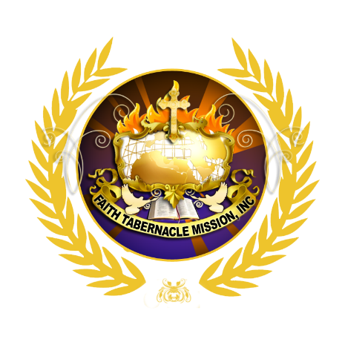
STAY CONNECTED

ONLINE
To learn more about the church, watch and listen to our weekly sermons, find out about groups and stay up to date with events please visit us online at FTMission.org

DOWNLOAD THE APP
Our app is one of the best way to stay connected. To download our app go to the Apple or Google Play app stores and search for Faith Tabernacle Mission. It's available for both iPhone and Android phones.

FTMI
To learn more about Faith Tabernacle Mission International, please visit their website at
www.FTMission.org

For details on how to get connected, check out our Connect Group Card. Visit www.FTmission.org, or call (813) 419-0920

